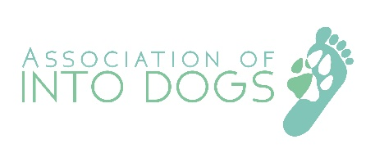
http://www.intodogs.org

Dear
Accreditation of Animal Behaviourists – Full/Professional Member of the Association of INTOdogs
For the first time, veterinary surgeons now have the opportunity to refer behaviour cases to suitably qualified practitioners who are members of independently verified organisations.
Professional members of The Association of INTODogs undergo an in-depth assessment, based on our stringent membership criteria, in order to be accepted as full members, and are entitled to add the title of INTODogs Certified Canine Behaviourist to their current qualification titles.
Our members would welcome veterinary referrals from your practice and would be more than happy to arrange an appointment to meet to discuss this further.
The local contact in your area is:
Name: Lisa Hird
Telephone number: 07834228774
Website: www.dogbehaviourclinic.co.uk
Email address: contactdogbehaviourclinic@gmail.com
Kind regards,
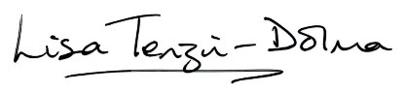
Lisa Tenzin-Dolma
Co -chair of The Association of INTO Dogs
Website: http://www.intodogs.org
Email: admin@intodogs.org

